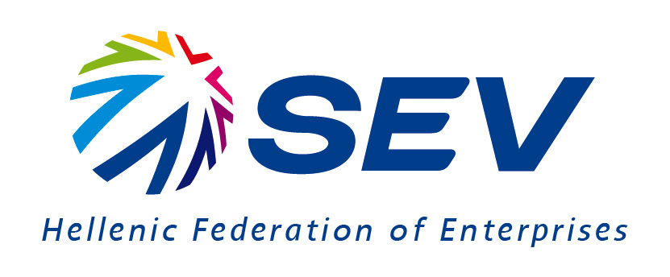

Welcome Address by Dr. George Xirogiannis
Deputy General Director of SEV
Ghana,25.11.2020

Your Excellencies,
Dear Mr. Mousouris,
Ladies and gentlemen,

the Hellenic African Chamber of Commerce and Development, is our partner in Sub-Saharan African missions,
Mr Mousouris thank you for hosting this meeting on business opportunities in Ghana.

The Covid-19 pandemic has disrupted business trips.
But we look forward, to a business trip in Ghana, as soon as we go back to normal.

Ladies and Gentlemen,
SEV is the largest business network in Greece.
We have a broad membership, covering all sectors of the economy,
including the largest industrial companies in Greece.

SEV is constantly working to expand trade and commercial ties around the world.

Today’s event aims to promote trade and business relationsbetween the two business communities.

Ladies and Gentlemen,
Ghana is one of the fastest growing economies in Africa, with 6,5%GDP growth in 2019.
In fact, Ghana is the first country in Sub-Saharan Africa to achieve the Millennium Development Goal 1, which is the target of reducing significantlypoverty.

Legislation in trade and investments positions the country as a regional bright spot.
Key strengths include policy consistency, open trade and foreign investment principles and stable institutions.

Businesses operating in the country enjoy incentives for projects in infrastructure, agriculture and manufacturing.

These are positive developments and offer excellent perspectives for investments which result to local prosperity as well as business growth.

Greece is also moving forward.
Legislation has been adopted by the new government that improves the business environment and attract investment.

Export volumes are doing well.
The overall climate of the economy is improving.

Ladies and Gentlemen,
The trade volume between Greece and Ghanais moving at relatively low levels.

It is precisely, this low level of trade that we wantto improve.

Our bilateral trade in 2019 was only27 million euros.
It has decreased by 38% compared to 2018.
This downfall is mainly due to the reduction of imports.

Our main exports to Ghana are manufactured goods, followed by machinery and transport equipment.

Also, there is already a Greek business presence in Ghana,like Mytilineos, Metron Energy Applications, etc.
But there are many unexploited opportunities in sectors like energy, construction, environmental services, food, pharma, and many others.

So, we need to do better.
Ladies and Gentlemen,
I strongly believe that there are many opportunities for Greek companies and local partners in Ghana.

I imagine that many of the companies participatingtoday, have extensive experience and presence in global markets.

So,let’s capitalize this opportunity to enhance cooperation, to strengthen economic ties and look to the future.

I wish you all success at today’s event
and thank you once again for your hospitality and time.

