Terina Kalogeropoulos Armenakis

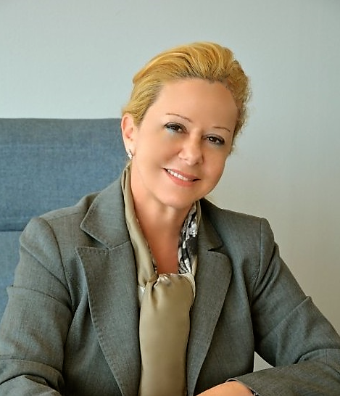
Mrs Terina Kalogeropoulos-Armenakis is Greek, born and raised in Addis Ababa to Greek parents.
She acquired her Bachelor of Economics, BSc. in the UK and attended a Master Degree, at Reading University on Economics and Politics of the EU.
Became a certified stockbroker in NY obtained the “Series 7” Certificate and also specialized in the bond markets with New York Institute of Finance.
Trained with Newbridge Securities in New York and Scrimgeour Vickers in London.
She launched her career in the Banking sector working for several years in banks such as Banque Indosuez London and Citibank in Athens.
Mrs. Kalogeropoulos Armenakis was appointed Honorary Consul General of Ethiopia in Greece in 1993 and she still serves in this position.
She is Vice President of the Hellenic African Chamber of Commerce, and she was elected President of the Consular Corps in Greece in 2008.
She is a founding member of several cultural and charity organizations in Greece, including the Drought Committee in Athens, which constructed a dam in Wollayita Zone, Ethiopia, the Support Ethiopian Children
Association "Lalibela", the Friendship among Nations and Friends of Marathon Association.
Mrs. Kalogeropoulos Armenakis speaks English, Amharic and French. She is married and is a mother to three sons.
Contact details:
19 Sygrou Ave, 11743 Athens, Greece
Tel: 210 9215067
e-mail: info@stahirealestate.com

