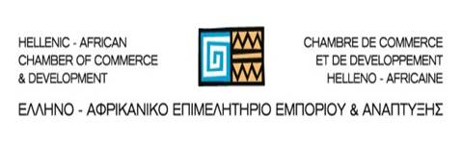

Workshop
“Business Opportunities in Sub-Saharan Africa”

Athens, Tuesday February 17th, 2015
SEV premises (5, Xenofontos, Syntagma sq.)

organized by: SEV International Activities Council
Hellenic-African Chamber of Commerce & Development
Registration
please send to: patsiavos@sev.org.gr

Company:

Activity:

Participant:

Position:

tel:

e-mail:

I wish to be notified for the business delegation to Sub-Saharan countries:
YES NO

I am interested for the following countries:

